AAUW Community Hub How to Self-Renew for Existing Members
The Community Hub allows existing members to log in and renew their membership and donate.
Login to your Personal Snapshot one of two ways.
- From the AAUW homepage click Log In in the upper right corner

- or go to my.aauw.org

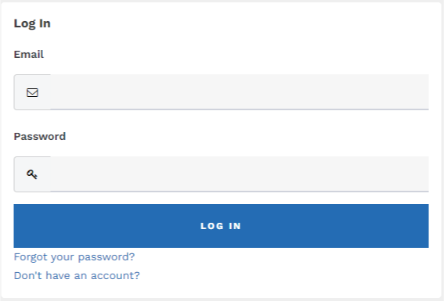
Click the Forgot your password? if you are an existing member but logging in to the Community Hub Personal Snapshot for the first time. If you’ve logged in before, enter email/password then click LOG IN.

On the Personal Snapshot page, scroll down and click . This takes you to the Membership Management page to enter your contact information. Then click Next.
(NOTE: For an individual renewing, the My Education Degrees field may already contain degree info)
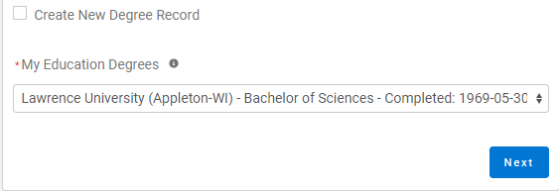
- Click Create New Degree Record if education is blank or to change it. Then click Next
- Enter education - for College/University, type the school name in the search to find and insert it

(For Date Conferred or Expected, use May 31 as a default month/date when unknown)
(If grad date is in the past, you will choose Lifetime or National membership on the next screen. If grad date is in the future, you will choose Student Associate or Graduate Student on the next screen.)
- Click Next
- Review rate information then Select Membership Type, then click Next

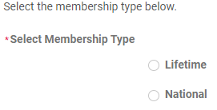

- Click Yes if you wish to add Branch or State memberships then click Next
- Select the Branch, scroll to bottom of the list, click Next
(NOTE: If multiple branches have been selected, you must choose one to be the primary.)
- Select the State, scroll to end of the list, click Next
- Click Yes or No to include a donation, then click Next
  - If Yes, enter amount in Donation Amount field, then click Next
  - If No, click Next
On Checkout page
- Review National, State and Branch dues
- Select Payment Type
  - Pay Now – Save Payment (If you wish to save a payment method for the branch, click Add, edit, or remove your saved payments in the My Payment Methods section) 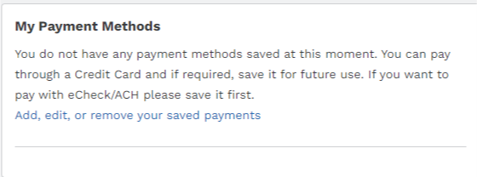
    - Choose Add Bank Account or Add Credit Card then complete all fields, agree to Terms and Conditions (if required), then click Save.

  - Pay Now – New Credit Card
    - Enter payment information, then click Submit

- Save confirmation for your records

