AAUW Community Hub How to Self-Join for New Member Prospects
Community Hub allows prospects to create an account to make donations and/or join AAUW.
From the Community Hub Login page:
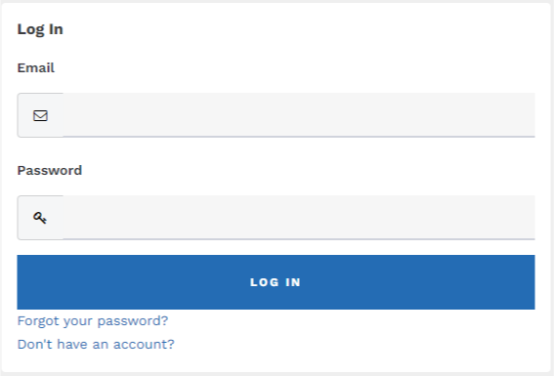

1. Click the Don’t have an account? link if you’re not yet a member or donor.
2. Enter the required information, then click Create Account to access your Personal Snapshot.

On the Personal Snapshot page, scroll down and click Join Now. This takes you to the Membership Management page to enter your contact information. Then click Next.
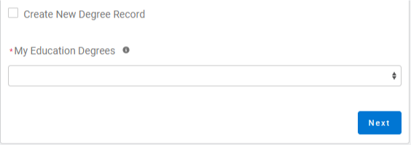
- Click Create New Degree Record then click Next
- Enter education - for College/University, type the school name in the search to find and insert it

(For Date Conferred or Expected, use May 31 as a default month/date when unknown)
(If grad date is in the past, you will choose Lifetime or National membership on the next screen. If grad date is in the future, you will choose Student Associate or Graduate Student on the next screen.)
- Click Next

- Review rate information then Select Membership Type, then click Next

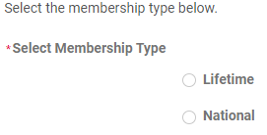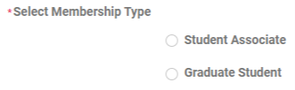

- Click Yes if you wish to add Branch or State memberships then click Next
- Select the Branch, scroll to bottom of the list, click Next
(NOTE: If multiple branches have been selected, you must choose one to be the primary.)
- Select the State, scroll to end of the list, click Next
- Click Yes or No to include a donation, then click Next
  - If Yes, enter amount in Donation Amount field, then click Next
  - If No, click Next
On Checkout page
- Review your membership selection.
- Enter Coupon Code, (if provided in advance of joining by your local branch, i.e. Shape the Future Campaign)
- Select Payment Type
  - Pay Now – Save Payment (If you wish to save a payment method for the branch, click Add, edit, or remove your saved payments in the My Payment Methods section) 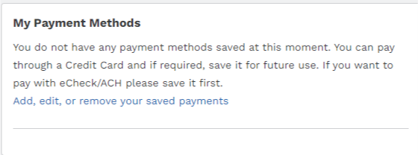
    - Choose Add Bank Account or Add Credit Card then complete all fields, agree to Terms and Conditions (if required), then click Save.

  - Pay Now – New Credit Card
    - Enter payment information, then click Submit
    - Save confirmation for your records

