AAUW Community Hub Add/Join New/Lapsed/Transfer Members for Branch Managers
The Add/Join New Members application allows the finance officers (as well as president/administrators and membership vice presidents) to process dues and donate on behalf of members who pay their dues to the branch by check.
Login to your Personal Snapshot one of two ways.
- From the AAUW homepage click Log In in the upper right corner

- or go to my.aauw.org

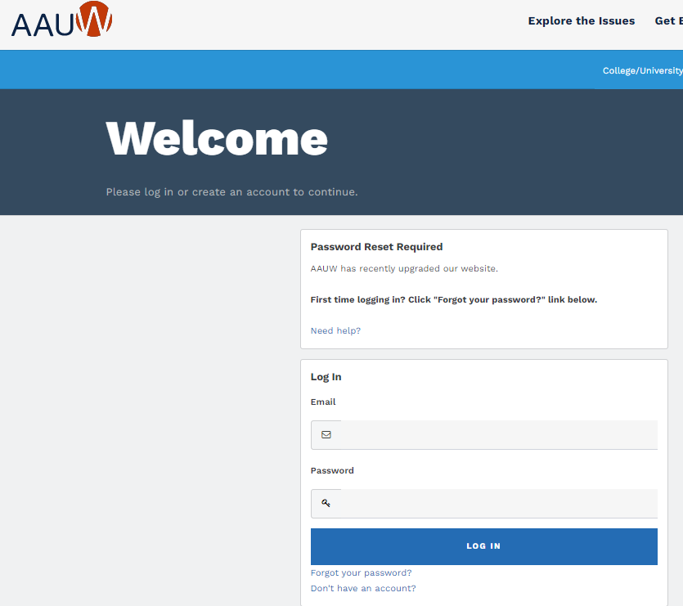
On Personal Snapshot page, click My Affiliations. Then, click on the ellipsis button to the right of the branch name and select Manage Roster.
On the Company Roster page, choose Actions and select Add Individual from the drop down

On the Add Individual page, enter info and then click SEARCH to see if an account record already exists.
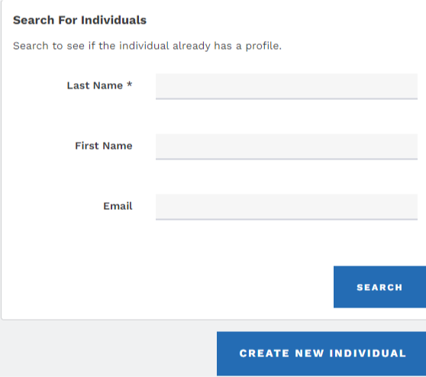
(NOTE: You may need to scroll down to see the search results)

- From Search Results, if the account record is found, click Add Individual. You will be returned to the Company Roster page with a confirmation message at the top.

- If no results are found OR if you’re not sure if the person is the correct individual, click Create New Individual
  - Complete contact information
  - Submit (This action returns you to the Company Roster page)
On Company Roster page, click Join Individuals
On Membership Management page:
- Select individual from drown down then click Next
- Review and make any necessary updates then click Next

(NOTE: For an individual added to the roster, the My Education Degrees field will be blank.)
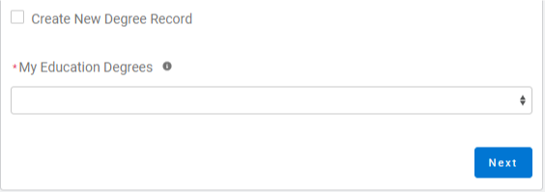
- Click Create New Degree Record then click Next
- Enter education - for College/University, type the school name in the search to find and insert it

(For Date Conferred or Expected, use May 31 as a default month/date when unknown)
- Click Next
- Review rate information then Select Membership Type

(If grad date is in the past, you will choose Lifetime or National membership on the next screen. If grad date is in the future, you will choose Student Associate or Graduate Student on the next screen.)

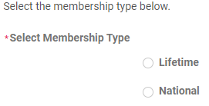

- Click Next. Click Yes to add Branch or State memberships then click Next
- SKIP to the bottom of the branch list WITHOUT selecting your branch, then click Next.
Note: When a check is collected and deposited to the branch’s bank account, you already have the branch dues. Subsequently the finance officer uses a branch debit/credit card to pay just national and state.

- Select the State, scroll to end of the list, click Next
- Click Yes or No if individual added a donation, then click Next
  - If Yes, enter amount in Donation Amount field, then click Next
  - If No, click Next
On Checkout page, review National and State dues for each order
- Add Coupon Code (ShapeTheFutureFY24), only if member paid 50% ($36) national dues
- Select Payment Type
  - Pay Now – Save Payment (If you wish to save a payment method for the branch, click Add, edit, or remove your saved payments in the My Payment Methods section) 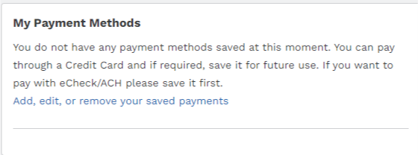
    - Choose Add Bank Account or Add Credit Card then complete all fields, agree to Terms and Conditions (if required), then click Save.

  - Pay Now – New Credit Card
    - Enter payment information, then click Submit
    - Save confirmation for your records

