May 2021
Resources, tips and tricks for AAUW state and branch leaders

Bragging on Branches (and States!)

Meet Our Latest Five-Star Awardees
Congrats to AAUW California and AAUW Washington—the latest states to hit earn stars this month in our Five-Star Recognition Program. Fantastic work to them on hitting their area goals. We’re thrilled to announce that AAUW Washington has earned all five stars, and we’re looking forward to seeing California cross the Five-Star finish line soon!
Kudos also to the following branches on their Five-Star achievements this month: (Alabama) Talladega County; (California) Mid-Peninsula, San Francisco; (Hawaii) Honolulu; (Illinois) Crystal Lake Area, Naperville; (Michigan) Farmington; (Pennsylvania) Bethlehem; (Virginia) Hampton, (Washington) Washington Online Branch.
And, last but not least, we applaud these branches for achieving all five stars: (Illinois) Naperville, (Pennsylvania) Bethlehem and (Washington) Washington Online Branch.

Success Stories
Get inspiration and advice from this month’s five-star branch leaders.

AAUW Easton (pennsylvania)
Adapt and Adjust
“Our dedicated board members strongly believe that advocacy, education, philanthropy and research are vital to advancing equity for women and girls. During the pandemic, we learned to adapt and adjust. We found ways to taste chocolate, work on a DIY art project and host a holiday trivia get together … all on Zoom. We even met suffragists in their period costumes, 100 years after women gained the right to vote. But we didn’t forget about our mission. Together we watched Picture a Scientist, which focused on women in STEM fields, followed by a great discussion. Local experts and legislators shared the obstacles of poverty and how it affects homelessness, domestic violence and education.
We honored a group of young artists who were inspired to create a video presentation on food inequity. We had discussions on education—from pre-Kindergarten to college—and a forum on early education and child care attended by candidates for local office. We awarded four scholarships to local graduating high-school women and increased our membership.
Our diversity, equity and inclusion interest group had important conversations, contacted legislators and wrote letters to local papers. We highlighted public policy issues on our active website, Facebook page and monthly newsletter. Our advice? Talk to other branches, divide the tasks, and provide programming that engages members.”
–AAUW Easton co-presidents, Nancy Kinzli and Karol D’Huyvetters
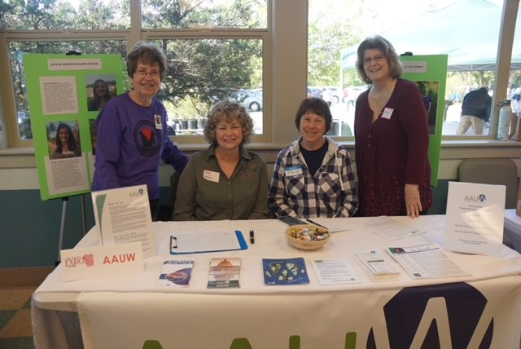
From left to right: Martha Huyler, Ramona Hall, Elaine Richards, Georgi Proulx
AAUW STANWOOD-CAMANO (WASHINGTON)

Engage and Inspire
Last year was challenging for many reasons, including Covid-19 and a contentious election. When the Stanwood-Camano branch began our membership year last July, we looked for ways to keep our branch active, engaged and inspired. The Five-Star program was a perfect way to do this. It touched on the major focus areas of the branch–membership, programs, public policy, governance, sustainability and advancement.
While the work initially seemed daunting, because we had already met some of the criteria in the prior year, we were able to have several “quick wins” when earning our stars, such as having named a Public Policy Chair, and attending our state’s annual Lobby Day.
In addition, we used the AAUW mission as a framework for designing our 2020-21 programs, which led to meetings around topics such as Title IX changes in our new federal administration. We looked for interesting mission-specific news and information to post on social media. We collaborated with other branches to learn what they were doing to attract and retain members. The Five-Star program is a great way to engage and inspire your branch!
–India Nishi, president

News & Resources

Welcome to AAUW’s New Leader
AAUW is pleased to welcome Katrina Sun Breese, our new senior director of institutional advancement. Katrina will be responsible for developing and implementing strategy for and managing all aspects of AAUW’s philanthropic and dues revenue-generating programs.
She has more than 15 years of experience in nonprofit fundraising, specializing in education and health care. Prior to joining AAUW, Katrina was the vice president of development and external affairs at APIA Scholars, the nation’s largest organization dedicated to supporting APIA (Asian and Pacific Islander Americans) student access to and success in higher education. Expect to hear more from her in the days and weeks to come!

Another Shot at 5-Star Success
It’s been a fantastic year for the Five-Star National Recognition Program, with more than 100 AAUW branches from 25 states earning stars for their work to advance gender equity. Branches and states have until June 30 to submit for Five-Star status in the existing program before we retool and relaunch this summer. Stay tuned for information about a virtual celebration in June, and register for our June 2 webinar about the program changes.

AAUW Gatherings: Put Safety First
Many members are understandably eager to return to in-person affiliate gatherings, but it’s important to follow all city, state and county guidance and be mindful of the risks. The pandemic isn’t over, and many of us regularly engage with young people and others who do not yet have access to the vaccine. For that and other reasons related to safety, caregiving and transportation, AAUW National will not consider bringing staff back to the office until after Labor Day.
It’s also worth remembering that virtual gatherings bring flexibility to your branch and allow you to expand your reach to new groups.

Be the Change
This June, AAUW will launch its Social Change Ambassadors Certificate Program, a virtual learning and networking experience for early- to mid-level professionals who want to make workplace practices more inclusive and equitable. Encourage the young professionals in your life to take advantage of this seven-week series of career-development courses. For $25, you can sponsor their journey.

AAUW McLean Thanks Our Stellar Staff
Thanks to the AAUW McLean Area (Virginia) branch for the generous gift they made to AAUW on behalf of our hardworking AAUW National Staff. We so appreciate AAUW McLean for recognizing our staff’s tenacity during an incredibly difficult year, and we hope they—and all members—know how much the staff appreciates their commitment in return. Team work makes the dream work!

Webinars to Watch
Our collection of informative equity webinars is expanding all the time. Many thanks API for their generous support of “Creating Inclusive Perspectives,” where we unpack the critical need for inclusive perspectives in various sectors. We also appreciate UC Berkeley Haas for graciously sponsoring “Equitable Recovery: Transforming Business Beyond COVID-19 session,” in which we covered what equity fluent businesses should look like in the COVID-era and beyond.

AAUW Welcomes New Legacy Circle Members
We gratefully acknowledge these visionary AAUW members and supporters who have recently joined the Legacy Circle: Nancy Ducharme (Florida) and Rosanne Krubsack (Iowa). By making a planned gift to AAUW National, each has embraced equity for future generations of women and girls as part of her personal legacy.
If you have included AAUW National in your estate plans, please contact AAUW Director of Advancement Heather Miller at 202.785.7766 to let us know so that we may celebrate you, too, as a new member of the Legacy Circle!

